Task 2: Multiple Sequence Alignment (MSA)

1. Objective
To select five protein sequences belonging to the same protein family, perform a Multiple Sequence Alignment (MSA), and identify conserved regions and motifs among them.

2. Protein Family and Sequences Used
Protein family: Hemoglobin subunit beta (HBB). Five reviewed (Swiss-Prot) sequences were retrieved from UniProtKB (https://www.uniprot.org), each from a different organism, to compare conservation across mammals and birds.
Accession | Entry Name | Organism (Common Name) | Gene | Length
P02057 | HBB_RABIT | Oryctolagus cuniculus (Rabbit) | HBB1 | 147 aa
P02070 | HBB_BOVIN | Bos taurus (Cow) | HBB | 145 aa
P02088 | HBB1_MOUSE | Mus musculus (Mouse) | Hbb-b1 | 147 aa
P68871 | HBB_HUMAN | Homo sapiens (Human) | HBB | 147 aa
P80216 | HBB_APTFO | Aptenodytes forsteri (Emperor penguin) | HBB | 146 aa

3. Method
- Reviewed FASTA sequences for the five entries above were downloaded from UniProtKB (Download → Selected → FASTA canonical, uncompressed).
- Sequences were imported into MEGA12 (Alignment Explorer).
- Multiple Sequence Alignment was performed using the built-in ClustalW algorithm (Alignment → Align by ClustalW) with default parameters: Gap Opening Penalty = 10.00, Gap Extension Penalty = 0.20 (multiple alignment stage), Protein Weight Matrix = Gonnet.
- Gaps ("-") were automatically inserted by the algorithm to maximise alignment of homologous residues across all five sequences.
- Fully conserved columns (identical residue in all five sequences) are marked with an asterisk (*) above the alignment.

4. Alignment Results
The screenshots below show the ClustalW alignment output generated in MEGA12. Positions marked with "*" in the header row are fully conserved across all five species; gap characters ("-") indicate an insertion/deletion relative to the other sequences.
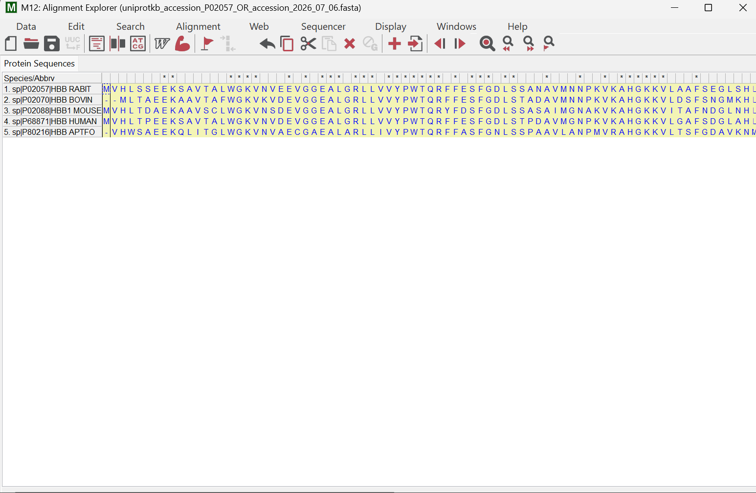
Figure 1: ClustalW alignment of five HBB sequences (Rabbit, Bovine, Mouse, Human, Emperor Penguin), N-terminal to mid-sequence region.

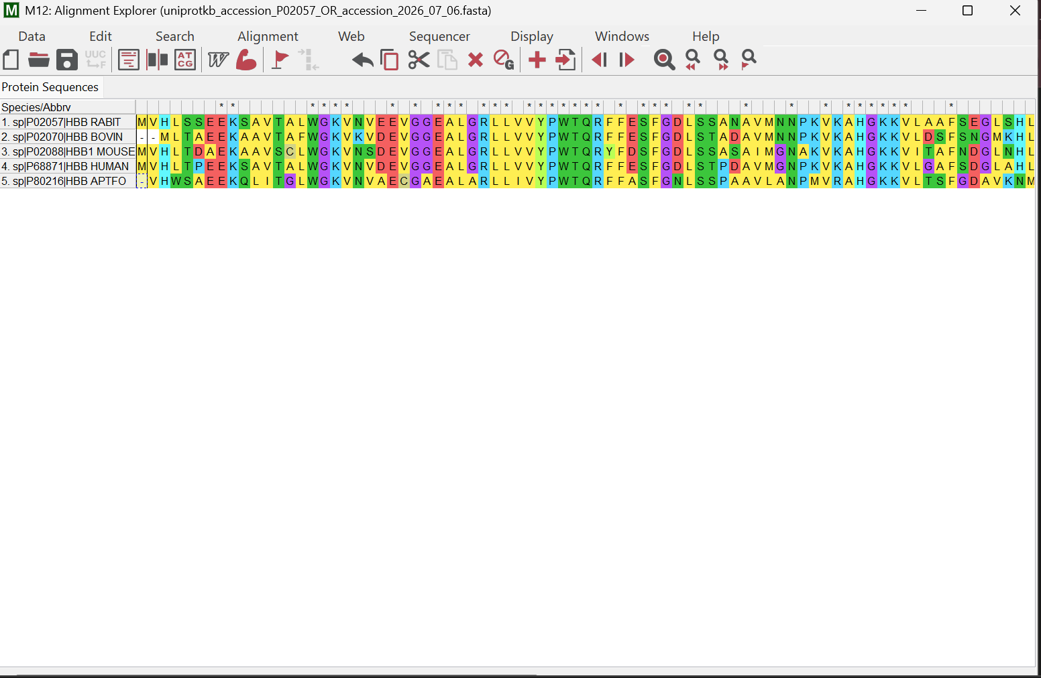
Figure 2: ClustalW alignment output, full-width view showing the complete aligned region with conservation markers (*).

5. Interpretation of Conserved Regions
The alignment shows a high overall degree of conservation among the five beta-globin sequences, which is expected since all five perform the same oxygen-transport function and diverged from a common ancestral gene.

5.1 Gap positions
Small gaps appear near the very start of the Bovine (HBB_BOVIN) and Penguin (HBB_APTFO) sequences. This means these two proteins are one residue shorter at the N-terminus compared to Rabbit, Mouse and Human. Because the alignment algorithm inserted a gap rather than a mismatch here, it indicates a genuine deletion event during evolution rather than simple sequence divergence.

5.2 Conserved stretches
A long, almost uninterrupted conserved block is visible in the middle of the alignment, spanning residues coding for the region “...GG(E/K)AL(G/E)R(L/M)LLVVYPWTQR(F/Y)FES(F)GDLS...” (approximate, read across the asterisk-marked columns). This region corresponds to part of the helical core of the globin fold that surrounds the heme-binding pocket.
A second conserved cluster appears further along the sequence around the “KAHG..K” motif, which lies close to residues known to stabilise the tertiary fold of the beta chain.

5.3 Biological significance
Beta-globin folds into eight alpha-helices (A–H) that create a hydrophobic pocket holding the heme group. Two histidine residues — the proximal histidine (His F8) and the distal histidine (His E7) — are essential across all vertebrate beta-globins: the proximal histidine directly coordinates the heme iron, while the distal histidine helps stabilise bound oxygen and prevent oxidation of the iron. Because these residues are catalytically essential, they and their immediate hydrophobic neighbours are expected to fall within the fully conserved ("*") columns of this alignment, which matches what is observed here.
The N-terminal valine, conserved across all five sequences, is also functionally important: it participates in binding 2,3-bisphosphoglycerate (2,3-BPG) and contributes to the Bohr effect (pH-dependent oxygen affinity), so its conservation across mammals and a bird reflects strong purifying selection on this residue.
Overall, the pattern of conservation — tight conservation in the helical, heme-contacting core and slightly more variability near the termini and surface loops — is consistent with the expected evolutionary behaviour of a functionally constrained oxygen-transport protein.

6. Conclusion
The MSA of five beta-globin sequences from Rabbit, Cow, Mouse, Human and Emperor Penguin confirms strong sequence conservation, particularly in regions responsible for heme binding and structural integrity of the globin fold. This supports the classification of these sequences as members of the same protein family and illustrates how functional constraints shape protein evolution.

